HyperionTD (GDD)

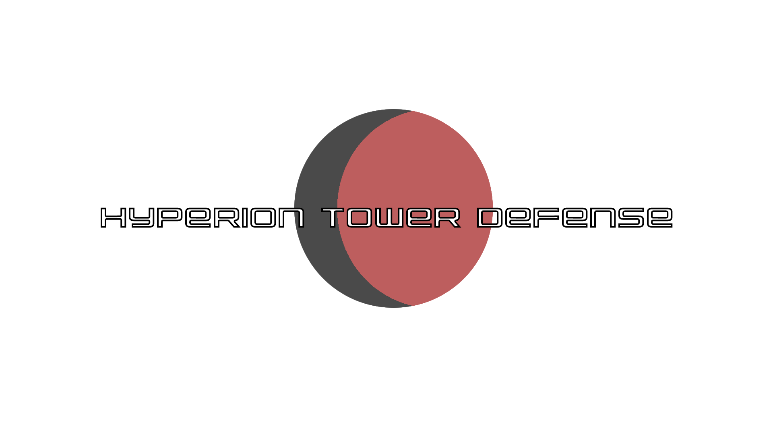

***‘Welcome to the battle, Commander.’*** – Roswell James Castaneda

|  |  |  |
| --- | --- | --- |
| Table of Contents  [1 Game Overview](https://n-xovwktmtjsnaxyc2mwes2xu7pohqedmdm6zjw5q-2lu-script.googleusercontent.com/userCodeAppPanel)  [2 High Concept](https://n-xovwktmtjsnaxyc2mwes2xu7pohqedmdm6zjw5q-2lu-script.googleusercontent.com/userCodeAppPanel)  [3 Unique Selling Points](https://n-xovwktmtjsnaxyc2mwes2xu7pohqedmdm6zjw5q-2lu-script.googleusercontent.com/userCodeAppPanel)  [4 Platform Minimum Requirements](https://n-xovwktmtjsnaxyc2mwes2xu7pohqedmdm6zjw5q-2lu-script.googleusercontent.com/userCodeAppPanel)  [5 Competitors / Similar Titles](https://n-xovwktmtjsnaxyc2mwes2xu7pohqedmdm6zjw5q-2lu-script.googleusercontent.com/userCodeAppPanel)  [6 Synopsis](https://n-xovwktmtjsnaxyc2mwes2xu7pohqedmdm6zjw5q-2lu-script.googleusercontent.com/userCodeAppPanel)  [7 Game Objectives](https://n-xovwktmtjsnaxyc2mwes2xu7pohqedmdm6zjw5q-2lu-script.googleusercontent.com/userCodeAppPanel)  [8 Game Rules](https://n-xovwktmtjsnaxyc2mwes2xu7pohqedmdm6zjw5q-2lu-script.googleusercontent.com/userCodeAppPanel)  [9 Game Structure](https://n-xovwktmtjsnaxyc2mwes2xu7pohqedmdm6zjw5q-2lu-script.googleusercontent.com/userCodeAppPanel)  [10 Game Play](https://n-xovwktmtjsnaxyc2mwes2xu7pohqedmdm6zjw5q-2lu-script.googleusercontent.com/userCodeAppPanel)  [10.1 Game Controls](https://n-xovwktmtjsnaxyc2mwes2xu7pohqedmdm6zjw5q-2lu-script.googleusercontent.com/userCodeAppPanel)  [10.2 Game Camera](https://n-xovwktmtjsnaxyc2mwes2xu7pohqedmdm6zjw5q-2lu-script.googleusercontent.com/userCodeAppPanel)  [10.2.1 HUD](https://n-xovwktmtjsnaxyc2mwes2xu7pohqedmdm6zjw5q-2lu-script.googleusercontent.com/userCodeAppPanel)  [10.2.2 Maps](https://n-xovwktmtjsnaxyc2mwes2xu7pohqedmdm6zjw5q-2lu-script.googleusercontent.com/userCodeAppPanel)  [11 Players](https://n-xovwktmtjsnaxyc2mwes2xu7pohqedmdm6zjw5q-2lu-script.googleusercontent.com/userCodeAppPanel)  [11.1 Metrics](https://n-xovwktmtjsnaxyc2mwes2xu7pohqedmdm6zjw5q-2lu-script.googleusercontent.com/userCodeAppPanel)  [11.2 States](https://n-xovwktmtjsnaxyc2mwes2xu7pohqedmdm6zjw5q-2lu-script.googleusercontent.com/userCodeAppPanel)  [11.3 Turrets](https://n-xovwktmtjsnaxyc2mwes2xu7pohqedmdm6zjw5q-2lu-script.googleusercontent.com/userCodeAppPanel)  [12 NPC](https://n-xovwktmtjsnaxyc2mwes2xu7pohqedmdm6zjw5q-2lu-script.googleusercontent.com/userCodeAppPanel)  [12.1 Enemies](https://n-xovwktmtjsnaxyc2mwes2xu7pohqedmdm6zjw5q-2lu-script.googleusercontent.com/userCodeAppPanel)  [12.1.1 Enemy States](https://n-xovwktmtjsnaxyc2mwes2xu7pohqedmdm6zjw5q-2lu-script.googleusercontent.com/userCodeAppPanel)  [12.1.2 Enemy Spawn Points](https://n-xovwktmtjsnaxyc2mwes2xu7pohqedmdm6zjw5q-2lu-script.googleusercontent.com/userCodeAppPanel)  [13 Art](https://n-xovwktmtjsnaxyc2mwes2xu7pohqedmdm6zjw5q-2lu-script.googleusercontent.com/userCodeAppPanel)  [13.1 Direction](https://n-xovwktmtjsnaxyc2mwes2xu7pohqedmdm6zjw5q-2lu-script.googleusercontent.com/userCodeAppPanel)  [13.2 Level Design](https://n-xovwktmtjsnaxyc2mwes2xu7pohqedmdm6zjw5q-2lu-script.googleusercontent.com/userCodeAppPanel)  [13.3 Audio](https://n-xovwktmtjsnaxyc2mwes2xu7pohqedmdm6zjw5q-2lu-script.googleusercontent.com/userCodeAppPanel)  [14 Procedurally Generated Content](https://n-xovwktmtjsnaxyc2mwes2xu7pohqedmdm6zjw5q-2lu-script.googleusercontent.com/userCodeAppPanel)  [14.1 Minimum Viable Product (MPV)](https://n-xovwktmtjsnaxyc2mwes2xu7pohqedmdm6zjw5q-2lu-script.googleusercontent.com/userCodeAppPanel)  [15 Wish List](https://n-xovwktmtjsnaxyc2mwes2xu7pohqedmdm6zjw5q-2lu-script.googleusercontent.com/userCodeAppPanel)  16 Bibliography   |  | | --- | |  | | Game Development Team Members    PRODUCER  Roswell James Castaneda  PRODUCTION MANAGER  Roswell James Castaneda  PRODUCTION COORDINATOR  Roswell James Castaneda  GAME DESIGNERS  Roswell James Castaneda  SYSTEMS/IT COORDINATOR  Roswell James Castaneda  PROGRAMMERS  Roswell James Castaneda  TECHNICAL ARTISTS  Roswell James Castaneda  AUDIO ENGINEERS  Roswell James Castaneda  UX TESTERS  Roswell James Castaneda |
|  |  |
|  |  |
|  |  |
|  |  |

|  |
| --- |
|  |

# 1 Game Overview

**Title:** Hyperion Tower Defense (HyperionTD)

**Platform:** PC Standalone + MAC OS

**Genre:** Tower Defense

**Rating:** (10+) ESRB

**Target:** Casual Gamers

Tower Defense Enthusiasts

Challengers

Achievement Hunters

RTS Gamers

**Release date:** May 10, 2020

**Publisher:** RSWL G.D.

**Description:**

Welcome to Hyperion Tower Defense. HyperionTD is an endless wave survival tower defense game where you take on the role as the Commander. As a Commander, you must design and build a defense grid against an alien force of polygons. Fight varying enemies, wave after wave, strengthening your attack power after every wave. Face fearsome bosses, testing the solidity of your defenses. Strategize to win the battle, utilizing three different turrets to capitalize on the enemy’s weaknesses. Get the highest score, by surviving the longest against other

**Tower Defense Description:**

A Tower Defense game can be described as a strategy game in which a player must build towers to defend against waves of enemies. The game objective of this genre is very simple, players must simply beat the level or survive the longest. The strategy part of the game genre involves knowing the enemy weakness, utilizing certain towers to exploit those weaknesses, and knowing where to put certain towers at which locations. For example, there might be a high health enemy that can’t be killed easily with standard turrets. To fight against this type of enemy you may need a tower that has a very high damage power output. What is described is a classic take on the genre, however this genre is very flexible. It is possible to add unique elements to the genre while also maintaining the basic elements of it. For example, a game titled *Sanctum 2*, is a Co-op first person shooter and tower defense game. Players can build turrets to defend against enemies, while the players themselves can also wield weapons to fight also.

# 2 High Concept

As mentioned, HyperionTD is a sci-fi tower defense game which utilizes the classic elements of the genre. Players must build turrets to defend against waves of different enemies. For each enemy they kill, the player’s score will increase, and they will receive money to build more turrets. This money received scales depending on the enemy type and the current wave the player is at. At the same time, the enemy scales with the waves too, adding considerable difficulty to the game. The game saves player data, meaning statistics of the highest score and highest wave achieved will be saved and shown to the player. Utilizing these elements means HyperionTD caters to a wide audience. The simplicity of the tower defense genre appeals to casual gamers. Having the basic elements of tower defense will appeal to the Tower Defense Enthusiasts and RTS gamers. And having a scoring system with an increasing difficulty will appeal to the achievement hunters and challengers.

# 3 Unique Selling Points

* Features Two Maps
* Three Unique Turrets
* Four types of enemies
* A high score system
* 3D Sci-Fi graphics

# 4 Platform Minimum Requirements

**PC and MAC Stand Alone**

**OS:** Windows 10, IOS

**Processor:** 2GHz Dual Core Processor

**Memory:** 4GB

**Graphics:** Direct X Compatible Card or other basic integrated graphics such as the Intel HD Integrated Graphics.

**Disk Space:** 150mb

# 5 Competitors / Similar Titles

* Sanctum
* Plants vs Zombies
* Bloons Tower Defense
* Kingdom Rush
* Arknights

# 6 Synopsis

In Hyperion TD, the player is a Commander for the Hyperion Federation. The Hyperion Federation is an Earth based government whose main objective is to search through space to find new resources for Earth. Upon finding these new resources, the Federation is met with a polygon shaped alien force. It is up to the Commander to stop this alien force by building a defense grid to defend the federation’s objectives.

# 7 Game Objectives

The Game Objective of HyperionTD is to survive the most waves and to get the highest score by building turret defenses that take advantage of the enemy’s weaknesses.

# 8 Game Rules

* Maps are enclosed in a 3D space and the player can only move their camera in this space.
* Players are only able to build on the purple tiles.
* Turrets are upgradeable and sellable.
* The upgrade cost will increase as the turret levels up.
* The sell value is 75% of the total turret value.
* Players can only build and upgrade turrets if they have enough money in the bank.
* Enemies will spawn in waves, and they get strong as the waves go by.
* Killing an enemy will increase the player’s score and will grant them money.
* The amount of money received also increases as the waves go.
* Stronger enemies will increase the player score and give money greater than weaker enemies.
* An Enemy boss will spawn every 10 waves.
* Wave wait time is 20 seconds.

# 9 Game Structure

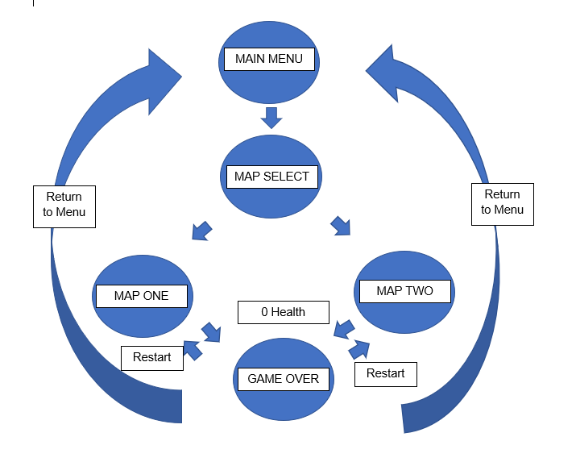

# 10 Game Play

## 10.1 Game Controls

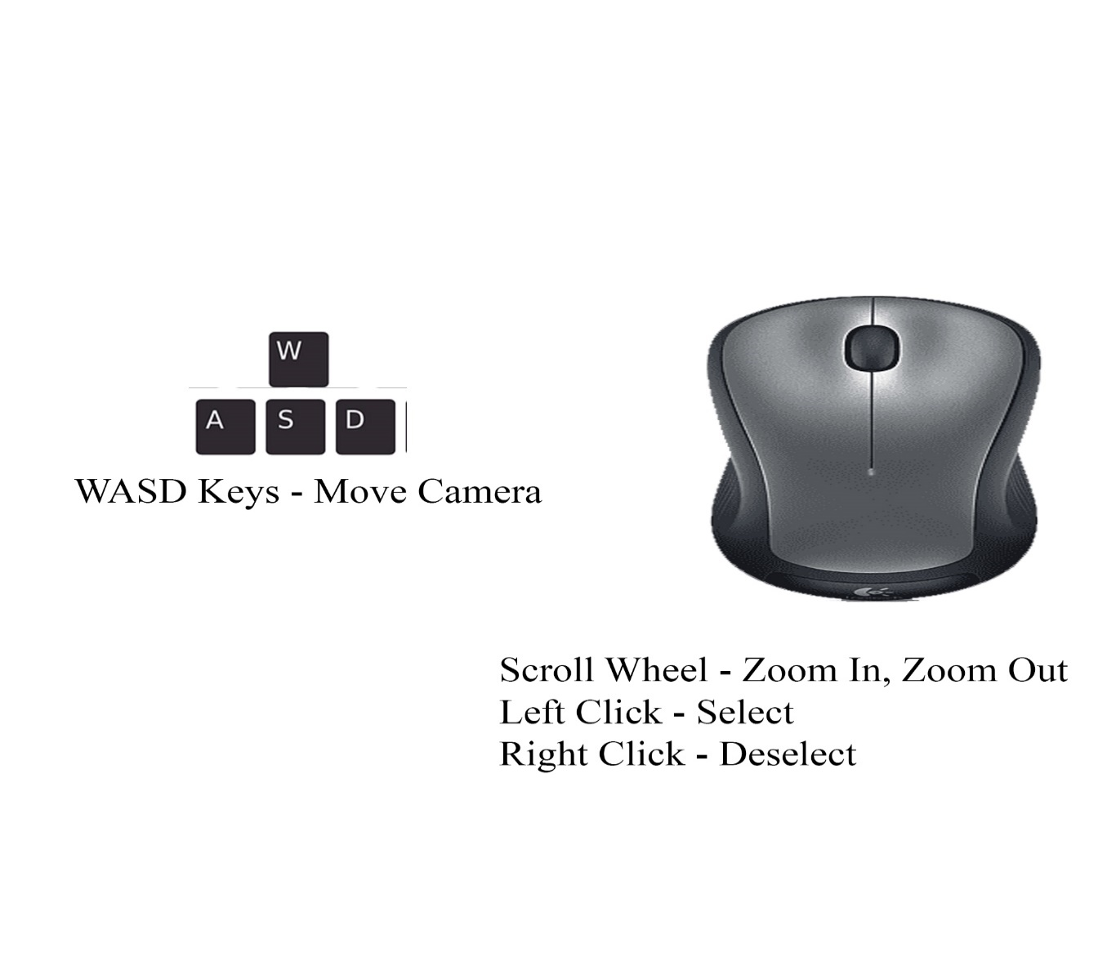

**Building**

1. Left Click turret button of the turret you want to build.
2. If wrong turret, press right click to deselect.
3. Move your mouse over the purple build tile. The tile will change color to yellow indicating that your mouse is hovering over the tile.
4. Left Click on that tile you want to place turret on.

**Upgrade/Selling**

1. Select the turret by left clicking on the tile with the turret you want to upgrade.
2. Press the upgrade button on the toolbar.
3. To sell, select the turret again, and press the sell button on the toolbar.

**Skip Waiting for Next Wave**

1. On the waves panel, there will be a button with two arrows. Press this button if you want to start the next wave. The button will be disable when you can’t skip to next wave.

## 10.2 Game Camera

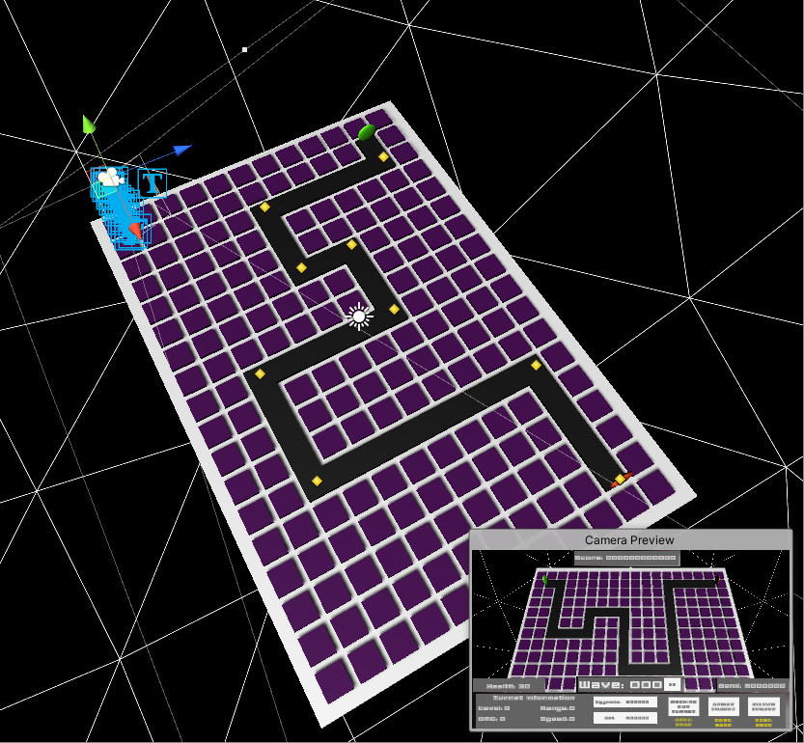

The Game Camera is orthographic and is angled at a 70 degree angle over the map to give a bird’s eye view of the map. The player can move the camera in a bounded 3D space using the WASD keys. The camera can also zoom in and out using the mouse scroll wheel.

### 10.2.1 UI

**In-Game UI**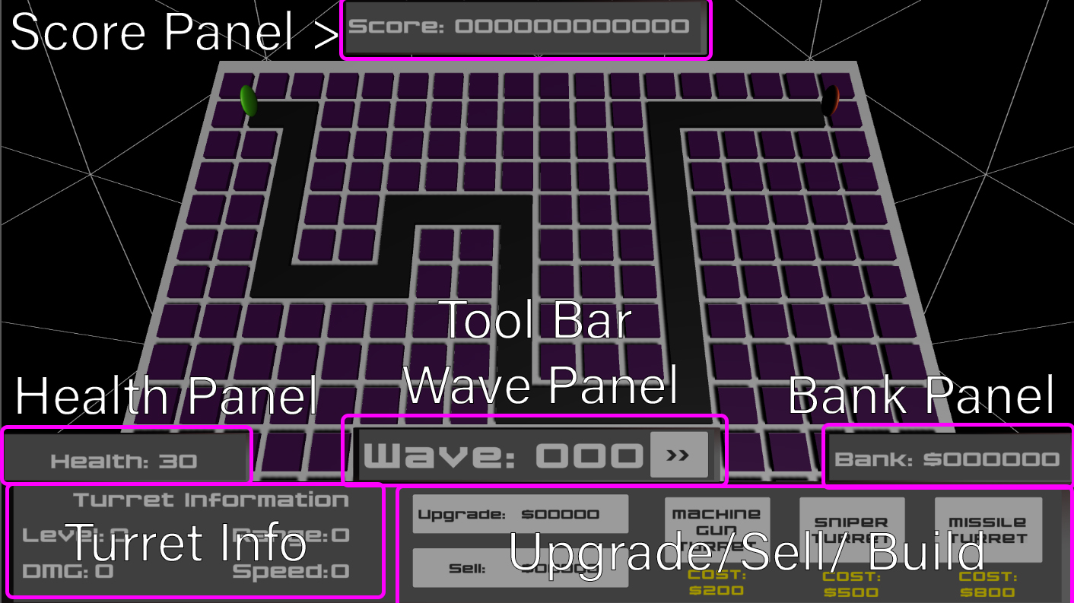

**Score Panel:**

Visual feedback of the score that the players accrued in the map

**Toolbar:**

UI that houses the Health, Wave, Bank Panel and the turret info and upgrade/sell/ build buttons.

**Health Panel:**

Visual feedback of the total health the player has left.

**Bank Panel:**

Visual feedback of the total money the player has accrued.

**Wave Panel:**

Visual feedback of the current wave the player is at. If the wave ended and the game state changes to wait for the next wave, the wave panel will show the timer till the next wave. Contains a button with two arrows indicating that you can fast forward to the next wave. This button will be disabled when the wave is still happening.

**Turret Info:**

Showcases the statistics of the currently selected turret. Statistics include the turret level, the damage, the range, and the speed.

**Upgrade/Sell/Build Buttons:**

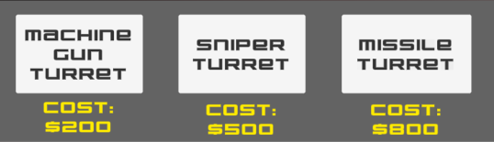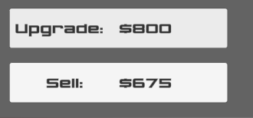

Buttons used to build, upgrade, and sell a selected turret. The buttons have text UI that tell the user the cost of performing the action indicated by the buttons. The build buttons have text to indicate which turret the player wants to build. The Upgrade and Sell button will have text UI elements that indicate to the player the cost of upgrading and selling a selected turret. If no turret is selected the upgrade and sell buttons will be disabled until a selection is made.

**Enemy Health Bar/Selection Marker/Range Indicator**

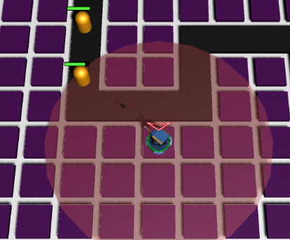

Enemies will have a green health bar over their head which allows visual feedback to the player the remaining health the specified enemy has left. When you select a turret, a red arrow will hover above the currently selected turret along with a red circle around the center. The red arrow gives visual feedback to the player that the turret is currently selected. The red circle around the turret gives visual feedback to the player of the current range the turret has. If the player upgrades the turret, the ring gets bigger.

**Pause Menu UI**

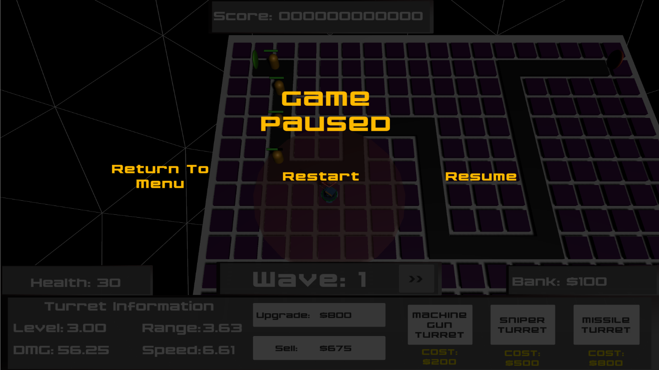

When the player presses the escape button, they are greeted with a pause menu UI. The UI has a UI text element “Game Paused” to tell the player the game is paused. The screen is also darker to indicate this. There are also three buttons that the player can click on. The return to menu button returns the player to the menu. The restart button restarts the current map the player is on. The resume button, resumes the game. The player can also resume the game by pressing escape again.

**Game Over UI**

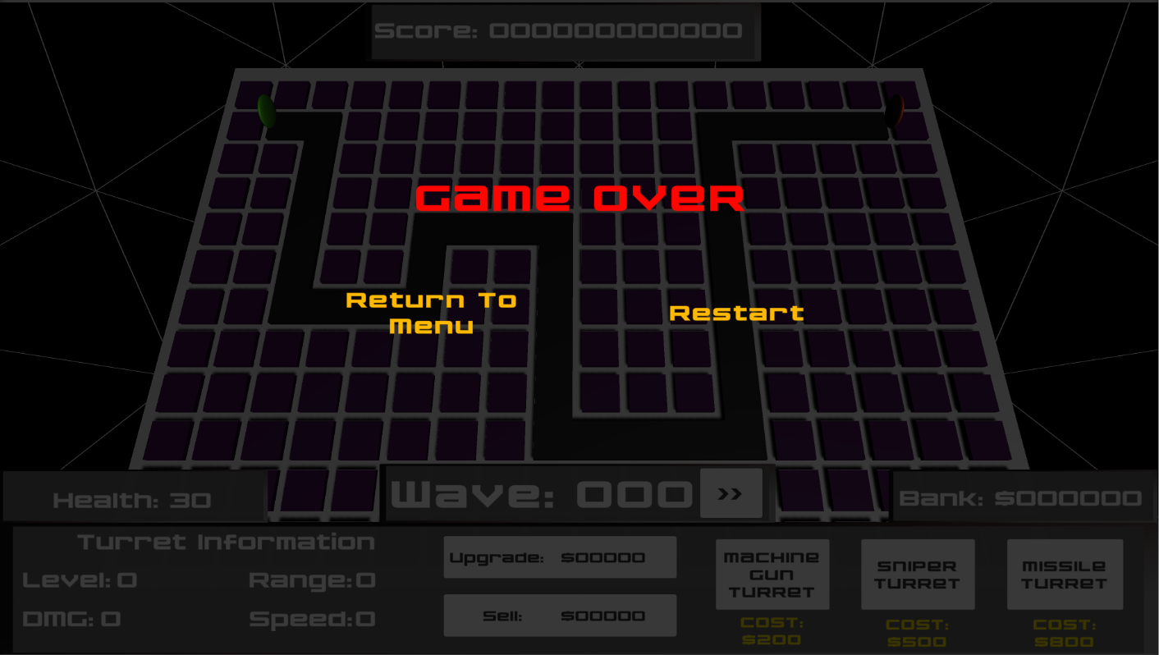

When the player’s health reaches 0, the game state changes to game over, and the player is greeted with the game over screen. Red UI Text saying “GAME OVER” tells the player they have lost. There is also a return to menu button and a restart button for the player to click on.

### 10.2.2 Maps

**Map One**

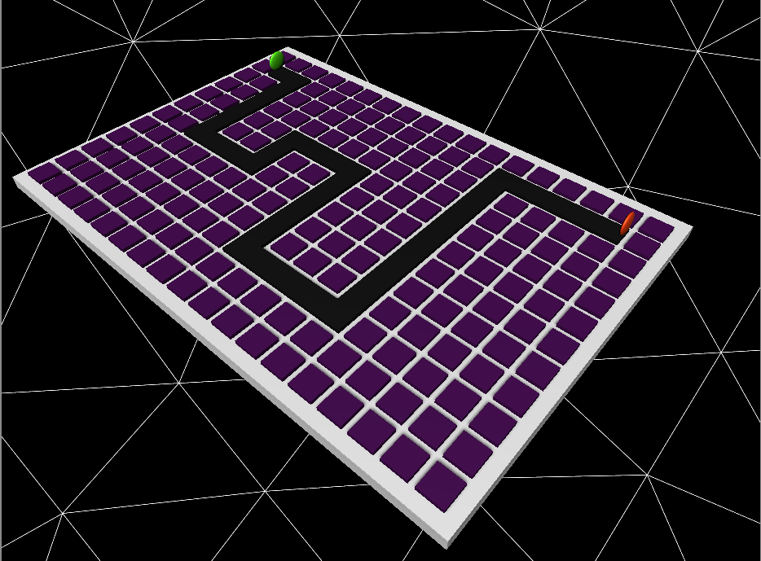

The first map of the game utilizes a W-shape enemy path design. Map One’s design is like this in order to make it easier. What makes this map easier is that the enemies will have to walk a greater distance and turn a lot more because of the abundant corners there are in the path. Because this map is easier, people new to the game will choose this first to familiarize themselves with the game. Furthermore, because the enemies travel distance is greater on this map, this means that games will be much longer.

**Map Two**

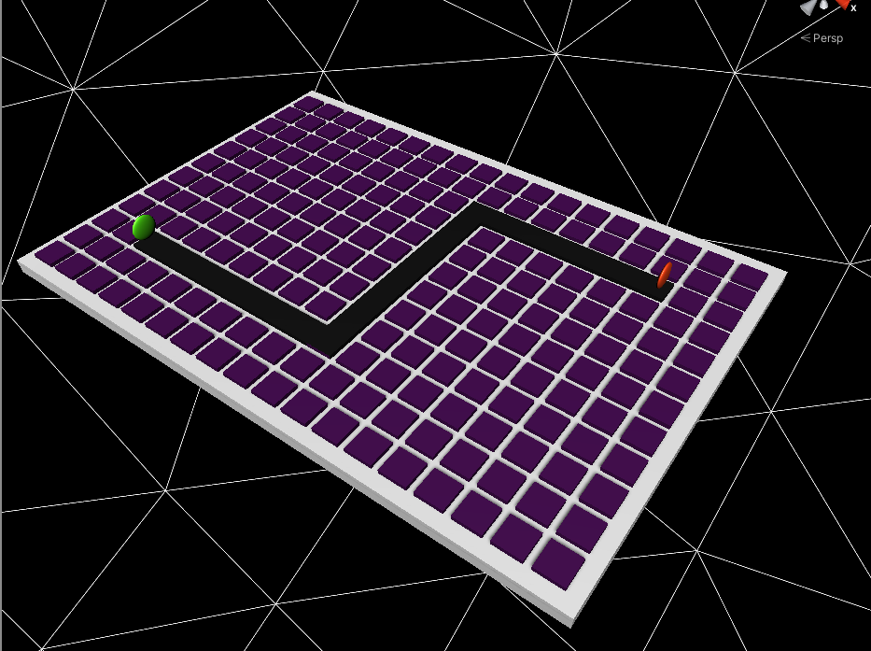

The second map of the game utilizes and S-shape enemy path design. This design is utilized to make the game harder. This design makes the game harder because the travel distance is shorter for the enemy and there is less corners for the player to work with. This map is implemented for players who want a challenge and to test their knowledge. Furthermore, the games on this map will be a lot shorter because the enemy have to travel a shorter distance.

# 11 Players

## 11.1 Metrics

**HEALTH**: 30 (Default)

The lives of the player.

**WAVES:** 0 (Default)

The number of waves the player survives on the map.

**Score:** 0 (Default)

The total score the player achieved on the map.

## 11.2 States

**Player Dead**

When the player’s health reaches zero, It’s a game over.

## 11.3 Turrets

**Turret Target Algorithm**

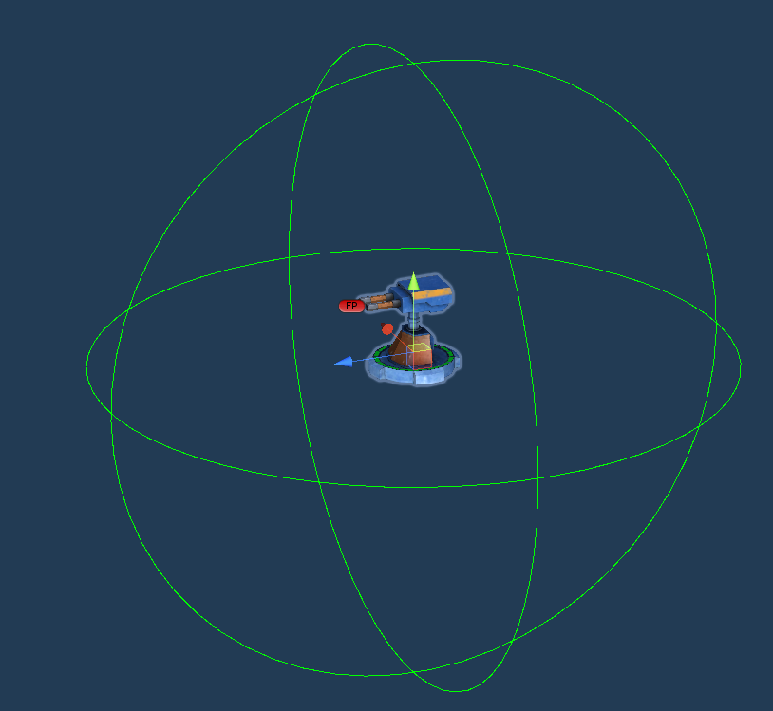

The turrets use a list-based algorithm to target enemies. Every turret has a sphere collider where it’s radius is the turret’s range of fire. If an enemy enters these colliders, it will be added to the turret’s list of enemies. The turret then chooses the first enemy on the list, and begins to aim, follow, and shoot at it. Once the enemy exits this collider, they are removed from the list. Because the target gets the first enemy in the list, they will always shoot at the first enemy nearest to the exit.

**Turret Attributes**

**Level:** The current upgrade level the turret is in.

**Max Level:** The total amount of times you can upgrade the turret.

**Turret Value:** The sum of all upgrades and the base cost of the turret.

**Cost:** The base cost to build the turret.

**Upgrade Cost:** The cost to upgrade the turret to the next level. This is calculated by taking the sum of the upgrade cost and 150% of the cost.

**Sell Cost:** The cost to sell the turret. This value is calculated by getting 75% of the total value of the turret.

**Damage:** The total damage that the turret does to an enemy. Scales by level and scaling is determined by the Damage Scale Factor.

**Damage Scale Factor:** The float value of how much the damage scales by percentage per level. If the scale factor is .5, then damage will scale by 50% each level.

**Range:** The total distance that the turret is able to hit an enemy. Scales by percentage per level.

**Range Scale Factor:** The float value of how much the range scales by percentage per level. If the scale factor is .5, then range will scale by 50% each level.

**Fire Rate:** The speed in which the turret fires. Scales by level and by the Fire Rate Scale Factor.

**Fire Rate Scale Factor:** The float value of how much the fire rate scales by percentage per level. If the scale factor is .5, then the fire rate will scale by 50% each level.

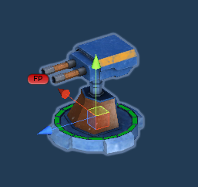**Machine Gun Turret**

Level: 1 (Default)

Max Level: 5 (Default)

Turret Value: $200 (Default)

Cost: $200 (Default)

Upgrade Cost: $200 (Default)

Sell Cost: $200 (Default)

Damage: 25 (Default)

Damage Scale Factor: .5

Range: 3

Range Scale Factor: .1

Fire Rate: 5

Fire Rate Scale Factor: .15

The basic turret of the game. Has a fast rate of fire, and a medium range, however, it has a low damage output. They do well against basic enemies and fast enemies.

**Sniper Turret**

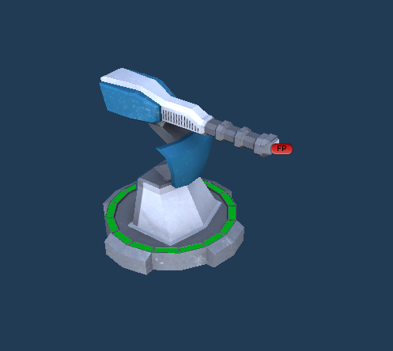

Level: 1 (Default)

Max Level: 5 (Default)

Turret Value: $500 (Default)

Cost: $500 (Default)

Upgrade Cost: $500 (Default)

Sell Cost: $500 (Default)

Damage: 125

Damage Scale Factor: .7

Range: .1

Range Scale Factor: .15

Fire Rate: .5

Fire Rate Scale Factor: .075

A turret that has superior damage, a long range, but has a low damage output. These turrets are good against boss enemies and slow large health enemies.

**Missile Turret**

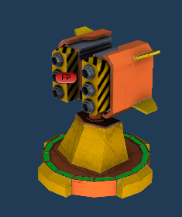Level: 1 (Default)

Max Level: 5 (Default)

Turret Value: $800 (Default)

Cost: $800 (Default)

Upgrade Cost: $800 (Default)

Sell Cost: $800 (Default)

Damage: 100

Damage Scale Factor: .3

Range: 3

Range Scale Factor: .2

Fire Rate: .3

Fire Rate Scale Factor: .05

A turret that can shoot missiles and deal AOE damage. The AOE radius is set two by default and can damage more than one enemy depending on how clumped up they are. The turret has a slow rate of fire and a medium range. They are good against enemies close together.

# 12 NPC

## 12.1 Enemies

**Enemy AI**

The AI of the enemy is basic. Once spawned, the enemy will search for a queue of waypoints. The enemy will move and follow those waypoints until they reach the exit. Colliding with the exit they get destroyed and the player loses a life. They do not shoot or do anything else.

**Enemy Attributes**

**Enemy Name:** The name of the enemy.

**Health:** the total health that the enemy has. Health scaled is calculated by the sum of the current health and the product of the current health and the scale factor.

**Move Speed:** The value of how fast the enemy moves towards the waypoints.

**Bounty:** The amount of money that the player will receive if they kill this enemy.

**Scale Factor:** A percentage value of how much the enemy scales per wave. If the scale factor is .2, the enemies health will scale by 20% each wave.

**Money Scale Factor:** A percentage value of how much the bounty increases per wave. If the money scale factor is .2, the enemies bounty will scale by 20% each wave.

**Enemy Score:** The amount of score the player will receive if they kill this enemy.

**Basic Enemy**

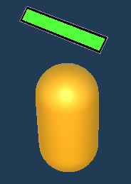Enemy Name: Basic Enemy

Health: 300

Move Speed: 2

Bounty: $25

Scale Factor: .25

Money Scale Factor: .1

Enemy Score: 100

The most basic enemy of the game. Has medium health and moves at a medium rate. Sometimes they might spawn fast and clump up, making them weak against the missile turret.

**Fast Enemy**

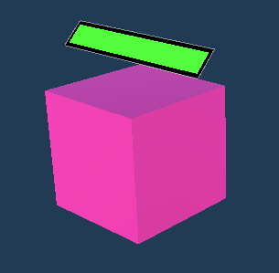

Enemy Name: Fast Enemy

Health: 150

Move Speed: 6

Bounty: $40

Scale Factor: .25

Money Scale Factor: .1

Enemy Score: 250

The fast enemy has a low health value but makes up for it with its movement speed. These enemies need to be taken out quickly meaning a fast fire rate by the machine gun turret will work the best against them.

**Slow Enemy**

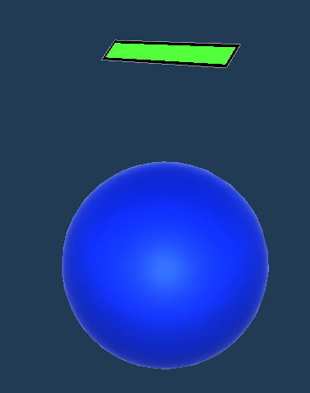

Enemy Name: Basic Enemy

Health: 800

Move Speed: 1

Bounty: $85

Scale Factor: .25

Money Scale Factor: .1

Enemy Score: 350

As mentioned in the name, the Slow enemy moves slow. However, this enemy has a lot of health, meaning machine gun turrets low damage will not work on them. A sniper turret will do the best against them.

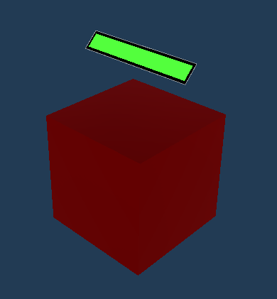**Boss**

Enemy Name: Basic Enemy

Health: 10000

Move Speed: .6

Bounty: $1000

Scale Factor: .2

Money Scale Factor: .1

Enemy Score:10000

The boss is the ultimate enemy in the game. It has a slow movement speed but has an incredible amount of health. You must use every turret at your disposal to go against the boss.

### 12.1.1 Enemy States

**Enemy Move**

The basic state of the enemy. The enemy will follow waypoints until it reaches the exit.

**Enemy Death**

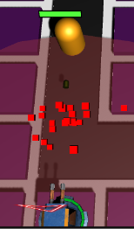When an enemy’s health reaches zero, they die and the player receives money and a score. They then play a death sound and instantiate a death effect, which is used to simulate blood coming out from an enemy. This effect gives visual feedback to the player that the enemy is dead.

### 12.1.2 Enemy Spawn System

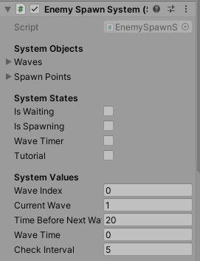

As mentioned, enemies spawn by waves. This is done by an enemy spawning script which utilizes a list of waves, states, and values. To make a wave, you must first create a class wave and put it into a list called “waves.” The waves have attributes such as name, number of enemies to spawn, spawn rate, and the game object of that enemy. The system then takes those the wave spawn rate, spawns the game object of the enemy and does this in a loop until all enemies have spawned. The system will then loop through the list of waves, linearly until it reaches the last index. Upon reaching the last index, the system will change the index back to the first wave on the list.

There are three main states in the game, the “is waiting” state, the “is spawning” state, and the “wave timer” state. The tutorial state is there to just halt the system. When the state is spawning enemies, it will go to the “is spawning” state. After all enemies have spawned the system will go to the “is waiting state” and will check if all enemies are dead at an interval defined by the Check Interval value. Once it checks that all enemies are dead, the state will change to wave timer, meaning that it will be counting down to the next wave.

### 12.1.3 Enemy Spawn Points

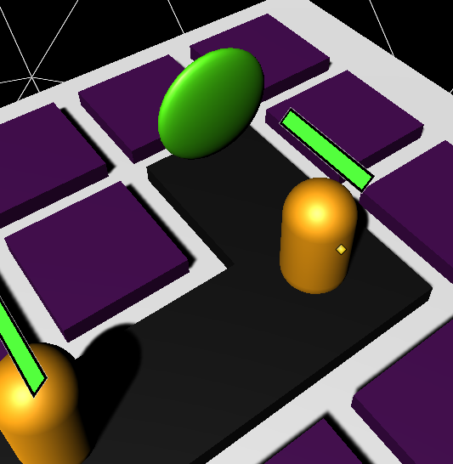

In the spawn system, there is a list of objects called spawn points. This list was originally created so that enemies could spawn randomly anywhere specified by the list of spawn points.

This was made for my second project Alpha One, but a classic tower defense game did not need to have enemies spawning at random points. In Hyperion TD enemies spawn at one point indicated by the green circle.

# 13 Art

## 13.1 Direction

Hyperion TD is a sci-fi fiction game, therefore the art, models and assets needed to feel like it was science fiction. To achieve this direction in Alpha One, the fonts, models, and assets are carefully chosen and made.

**Fonts and Logo Design**

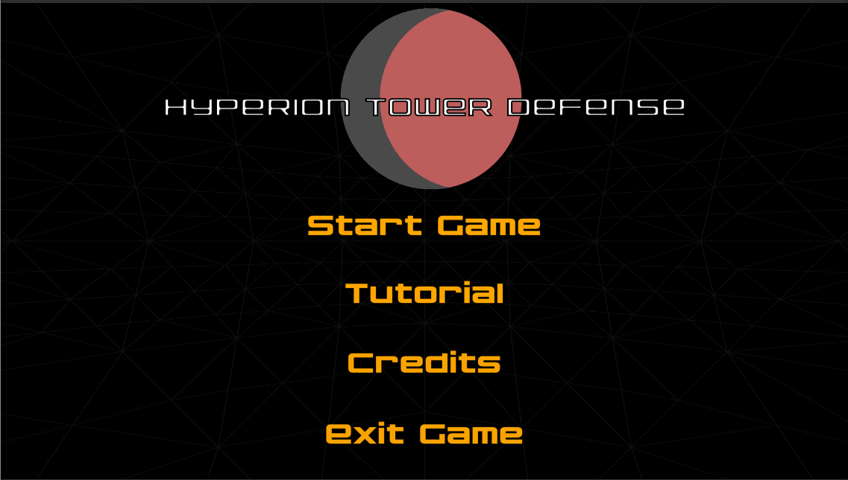

The fonts in the game have a robotic style. The game uses the Nakadai font from Da Font and this font creates a technological feel that sci-fi universes have. As can be seen from the main menu, this feeling is achieved.

The logo of Hyperion TD needed to be simple while still maintaining that sci-fi feel. Thus, a simple circle with a dark color contrasting with a lighter color was made. When people think of sci-fi they think of space, so the circle with two tone colors is used to visualize a planet with a dark side and a light side. The red tint is an inspiration of the red planet, Mars, where people think aliens are hiding. However, the game does not take place on the planet mars, and the color is just used as a metaphor for it.

**Models**

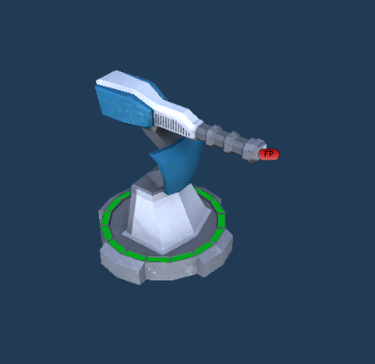

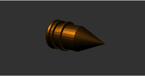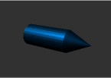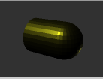

The turret models for Hyperion TD were borrowed from the Unity Asset Store. These models were created by Vertex studios and they were the perfect fit for the game. The turret models were very mechanical and fit the sci-fi theme.

The bullet models for the turrets were created by me. The bullets are all color coded and have slight differences to know which bullet goes with which. The Missile bullet is a bronze/gold color and has rings to give the model more depth. The tip of the missile is sharp to give the image that it has a lot of damage. The sniper bullet is color coded blue and is a bit longer than the usual bullet and has a sharp tip to give the feeling like it's a penetrating bullet. The machine gun bullet is color coded a bright yellow and has a spherical tip like a real bullet.

**UI**

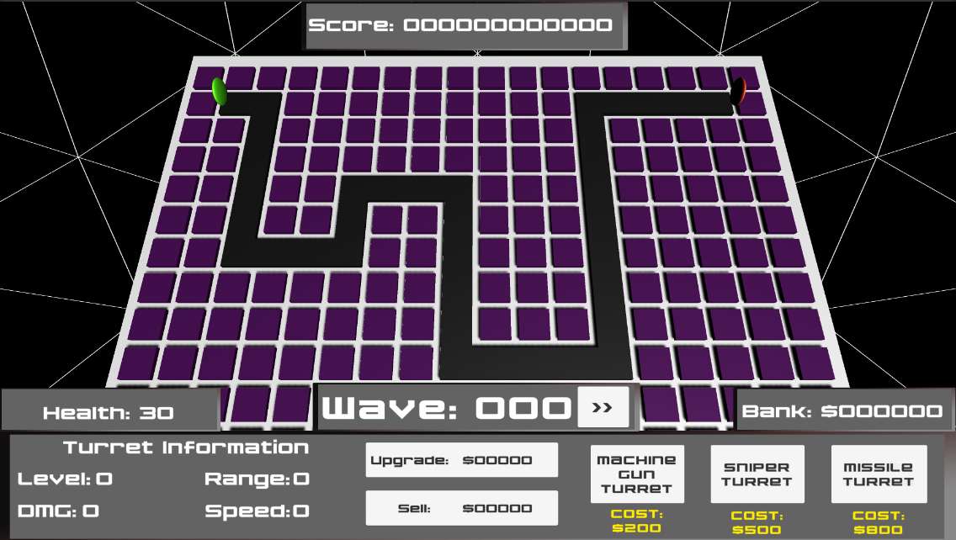

The game’s UI is designed by myself. Using photoshop I made rounded rectangles with a dirty brown gradient to give that metallic feel. The In-Game UI uses a toolbar design inspired by StarCraft’s UI, as Tower Defense games are much simpler strategy games.

## 13.2 Level Design

The level design for Hyperion TD is simple. The enemy paths, map area, and the build tiles are all square shaped because squares usually are uniform and technical. The Skybox which surrounds the map area uses the Unity Wire Mesh material. This is used because, again, the lines give off a sci-fi simulation ambience.

## 13.3 Audio

**BGM**

Background music is included into the game to further exacerbate the sci-fi ambience. The main menu and the maps each have their own background music and the genre of music used is Electronic Dance Music (EDM), specifically the sub-genre, Mid-Tempo. Mid-Tempo EDM is used because the genre is defined by the pounding beats and distorted synths of electro house with a dark atmosphere. When you think sci-fiction or technology you think of electronics, so the electronic part of EDM fits with that feeling. Furthermore, the dark atmosphere of Mid-Tempo adds to the game’s “Epic” feel and action.

**Main Menu BGM:** Daft Punk – Rinzler (1788-L Remix)

**Map One BGM:** K?D x Varien – Catherine

**Map Two BGM:** Virtual Self – Angel Voices (Among the Others Remix)

**SFX**

There are two sound effects that I added to the game, it is an enemy death SFX and missile explosion. There are only two sounds because adding, for example, gun sounds after each shot would cause make the audio messy. An enemy death SFX would give the player audible feedback that the turrets are shooting and are eliminating the enemy. The missile explosion sound effect was created so that the missile turrets feel as if they are doing work. Furthermore, the missile is a slow firing turret, therefore having a missile explosion effect for each shot would not make the audio as messy as having it on the machine gun turret.

To create these sound effects, I recorded sounds from my microphone and edited them on Ableton Live. The enemy death effects were created by making loud tapping sounds on my work desk. I equalized the sound so that it wasn’t too loud and got to where the sound effects is in the game. The explosion effect was also created using my work desk, but I lightly slammed my fist to it. My microphone is very sensitive, so when I slammed my fist to the desk, it made a deep and bass driven bang sound. I edited this sound effect to where it is now by dampening the bass and lowering the distortions.

# 14 Procedurally Generated Content

## 14.1 Minimum Viable Product (MPV)

* Built for the PC platform.
* One Map.
* One type of enemy that scales by wave.
* One type of boss.
* A scoring system.

# 15 Wish List

* **More Maps:** Adding more maps will increase the replay value of the game.
* **More Enemies:** Adding more enemies will diversify the game and bring in new strategies and content.
* **More Turrets:** Adding more turrets will again diversify the game and create new strategies and weakness against the enemies.
* **Upgrade Shop:** Adding a shop system that will convert your score into points to purchase more turret upgrades and turrets.

# 16 Bibliography

|  |  |  |
| --- | --- | --- |
| **FILE NAME** | **AUTHOR** | **REFERENCE (If Applicable)** |
| MTGBullet.fbx | Roswell James Castaneda | N/A |
| Missile.fbx | Roswell James Castaneda | N/A |
| SniperBullet.fbx | Roswell James Castaneda | N/A |
| Turret_1.fbx + Material | Vertex Studio | <https://assetstore.unity.com/packages/3d/props/weapons/turrets-pack-9872> |
| Turret_2.fbx + Material | Vertex Studio | <https://assetstore.unity.com/packages/3d/props/weapons/turrets-pack-9872> |
| Turret_3.fbx + Material | Vertex Studio | <https://assetstore.unity.com/packages/3d/props/weapons/turrets-pack-9872> |
| Turret_4.fbx + Material | Vertex Studio | <https://assetstore.unity.com/packages/3d/props/weapons/turrets-pack-9872> |
| Turret_5.fbx + Material | Vertex Studio | <https://assetstore.unity.com/packages/3d/props/weapons/turrets-pack-9872> |
| Turret_6.fbx + Material | Vertex Studio | <https://assetstore.unity.com/packages/3d/props/weapons/turrets-pack-9872> |
| Materials Folder (ALL) | Roswell James Castaneda | N/A |
| MGTBullet.prefab | Roswell James Castaneda | N/A |
| Missile.prefab | Roswell James Castaneda | N/A |
| SniperBullet.prefab | Roswell James Castaneda | N/A |
| EnemyDeathEffect.prefab | Roswell James Castaneda | N/A |
| MissileExplosion.prefab | Roswell James Castaneda | Brackeys: <https://www.youtube.com/watch?v=LJLWNnqAjQ4&list=PLPV2KyIb3jR4u5jX8za5iU1cqnQPmbzG0> |
| BasicEnemy.prefab | Roswell James Castaneda | N/A |
| Boss.prefab | Roswell James Castaneda | N/A |
| FastEnemy.prefab | Roswell James Castaneda | N/A |
| SlowEnemy.prefab | Roswell James Castaneda | N/A |
| BuildSquare.prefab | Roswell James Castaneda | Brackeys: <https://www.youtube.com/watch?v=beuoNuK2tbk&list=PLPV2KyIb3jR4u5jX8za5iU1cqnQPmbzG0&index=1> |
| EnemyPath.prefab | Roswell James Castaneda | Brackeys: <https://www.youtube.com/watch?v=beuoNuK2tbk&list=PLPV2KyIb3jR4u5jX8za5iU1cqnQPmbzG0&index=1> |
| MGT.prefab | Roswell James Castaneda | Brackeys: <https://www.youtube.com/watch?v=QKhn2kl9_8I&list=PLPV2KyIb3jR4u5jX8za5iU1cqnQPmbzG0&index=4> |
| MissileTurret.prefab | Roswell James Castaneda | Brackeys: <https://www.youtube.com/watch?v=QKhn2kl9_8I&list=PLPV2KyIb3jR4u5jX8za5iU1cqnQPmbzG0&index=4> |
| SniperTurret.prefab | Roswell James Castaneda | Brackeys: <https://www.youtube.com/watch?v=QKhn2kl9_8I&list=PLPV2KyIb3jR4u5jX8za5iU1cqnQPmbzG0&index=4> |
| CameraMovement.cs | Roswell James Castaneda | Brackeys: <https://www.youtube.com/watch?v=qokYflgxU6M&list=PLPV2KyIb3jR4u5jX8za5iU1cqnQPmbzG0&index=7> |
| Enemy.cs | Roswell James Castaneda | Brackeys: <https://www.youtube.com/watch?v=aFxucZQ_5E4&list=PLPV2KyIb3jR4u5jX8za5iU1cqnQPmbzG0&index=2> |
| EnemyMovement.cs | Roswell James Castaneda | Brackeys: <https://www.youtube.com/watch?v=aFxucZQ_5E4&list=PLPV2KyIb3jR4u5jX8za5iU1cqnQPmbzG0&index=2> |
| EnemySpawnSystem.cs | Roswell James Castaneda | Brackeys: <https://www.youtube.com/watch?v=Vrld13ypX_I> |
| Player.cs | Roswell James Castaneda | N/A |
| PlayerData.cs | Roswell James Castaneda | Brackeys: <https://www.youtube.com/watch?v=XOjd_qU2Ido> |
| PlayerSingleton.cs | Roswell James Castaneda | InfallibleCode: <https://www.youtube.com/watch?v=mpM0C6quQjs> |
| BuildSquare.cs | Roswell James Castaneda | Brackeys: <https://www.youtube.com/watch?v=t7GuWvP_IEQ&list=PLPV2KyIb3jR4u5jX8za5iU1cqnQPmbzG0&index=6> |
| BuildSystem.cs | Roswell James Castaneda | Brackeys: <https://www.youtube.com/watch?v=t7GuWvP_IEQ&list=PLPV2KyIb3jR4u5jX8za5iU1cqnQPmbzG0&index=6> |
| Bullet.cs | Roswell James Castaneda | Brackeys: <https://www.youtube.com/watch?v=oqidgRQAMB8&list=PLPV2KyIb3jR4u5jX8za5iU1cqnQPmbzG0&index=5> |
| BulletPoolSystem.cs | Roswell James Castaneda | Brackeys: <https://www.youtube.com/results?search_query=brackeys+object+pooling> |
| Turret.cs | Roswell James Castaneda | Brackeys: <https://www.youtube.com/watch?v=QKhn2kl9_8I&list=PLPV2KyIb3jR4u5jX8za5iU1cqnQPmbzG0&index=4> |
| TurretShoot.cs | Roswell James Castaneda | Brackeys:  <https://www.youtube.com/watch?v=oqidgRQAMB8&list=PLPV2KyIb3jR4u5jX8za5iU1cqnQPmbzG0&index=5> |
| Tutorial.cs | Roswell James Castaneda | N/A |
| MainMenu.cs | Roswell James Castaneda | N/A |
| GameStateSystem.cs | Roswell James Castaneda | N/A |
| InGameUI.cs | Roswell James Castaneda | N/A |
| SaveSystem.cs | Roswell James Castaneda | Brackeys:  <https://www.youtube.com/watch?v=XOjd_qU2Ido> |
| TurretInfoPanel.cs | Roswell James Castaneda | N/A |
| Daft Punk - Rinzler ( 1 7 8 8 - L _ R E M I X ) f.mp3 | 1788L, Daft Punk | <https://soundcloud.com/1788-l/daft-punk-rinzler-1-7-8-8-l-r-e-m-i-x> |
| Virtual Self - Angel Voices (Among the Others Flip).mp3 | Virtual Self, Among the Others | <https://soundcloud.com/among-the-others/angel-voices-ato-flip> |
| kid x varien - catherine.mp3 | K?D, Varien | <https://soundcloud.com/whoskid/kid-x-varien-catherine> |
| EnemyDeath.mp3 | Roswell James Castaneda | N/A |
| Missile Explosion.mp3 | Roswell James Castaneda | N/A |
| Arrow.png | oglsdl | <https://opengameart.org/content/glow-arrow> |
| MapOne.png | Roswell James Castaneda | N/A |
| MapTwo.png | Roswell James Castaneda | N/A |
| UnityProject3GameLogo.png | Roswell James Castaneda | N/A |
| UnityProject3UI.png | Roswell James Castaneda | N/A |
| WhiteSquare.png | Roswell James Castaneda | N/A |
| Nakadai italic.otf | DaFont | <https://www.dafont.com/nakadai.font> |
| Nakadai.otf | DaFont | <https://www.dafont.com/nakadai.font> |